 TDI Weekly Report
Date (01-JAN-2016) | Vessel Name | Printed name of person filing report
Complete this report, scan as pdf and e-mail to dpa@tdi-bi.com along with scans of the docs below on Friday of each week.
Then file originals on the bridge.

Naming Protocols: Use the naming protocol for both the name of the file and the subject line of your email. The naming protocol for this Weekly Report is: BOAT-WEEKLY REPORT-DD-MON-YYYY Example: The Proteus would use: PRT-WEEKLY REPORT-19-JAN-2016

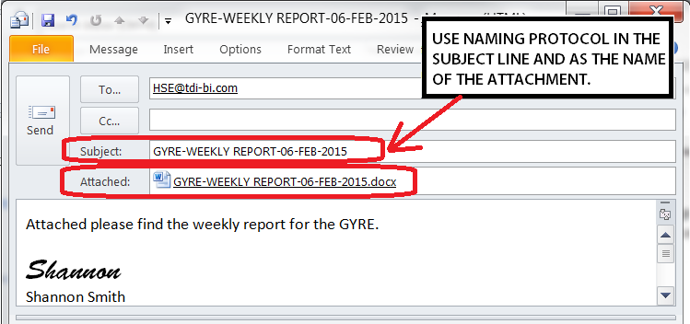

Documents to include as attachments with the Weekly Report e-mail:
Report: Name Protocol | What it is/ Where to find it | What to send
HSE Weekly Meeting  BOAT-HSE-DD-MON-YYYY | This is one of the special topics chosen from the ship web page “HSE Toolbox Talks”, can be viewing a safety video but still need a sign in sheet. | Sign in sheet only
Galley Weekly Inspection  BOAT-GALLEY-DD-MON-YYYY | The form for this is on the TDI Forms page (http://linux.geodatapub.com/publicweb/TDI%20forms.html) under Departmental Cross audits & Galley Inspection. | PDF or XLS file of the Galley Findings page only
Quarterly Drill Tracking Sheet  BOAT-DRILLS-DD-MON-YYYY | The form for this is on the TDI Forms page (http://linux.geodatapub.com/publicweb/TDI%20forms.html) under the Bridge Section | PDF or XLS file

DRILLS: Drills are entered in the NS5 Quality and Compliance module (NOT Maintenance) as a drill. --The TDI standard drill sign in sheets are located on the TDI forms page. The Quarterly Drill tracking Sheet and instructions should be posted on the bridge for constant review, reminder and update.
Drill type | Date 11-JAN-16 | NS5 Drill # |  | Drill type | Date 11-JAN-16 | NS5 Drill #

Weekly CAR Report

Does this vessel have any open CARs at this time? NO YES [If yes, complete the CAR Weekly Update below]

NS5 CAR # | Topic | Progress made since last week | Current Status of CAP  (Proposed, accepted, implemented, completed)

Safety Cards- Statistics for the week | HSE Key Performance Indicators
[Enter number of cards next to appropriate category. ]
# of cards | Category (best fit)
 | PPE
 | Tools and Equipment
 | Safety Attitude
 | Permit to Work
 | Housekeeping
 | Body Mechanics (lifting, handling)
 | Maintenance/ Inspections
 | Procedures
 | Pre-Job Inspections
 | Communication
 | Positive Comment cards
 | Total # Cards This Week

 | # | Meetings/ Trainings/ JSAs/ Inspections
 |  | Safety Meetings (goal is daily)
 |  | Crane Inspections (every time used)
 |  | JSAs conducted (standard or unplanned)
 |  | Permits completed
 |  | Hazard Hunts (goal of 1 per month)
 |  | Lifting gear inspections (goal of 1 per month)
 |  | PPE inspections (goal of 1 per month)
 |  | Contractor Safety Meetings

Other HSE issues or concerns:

